OFFICIAL CALL
GFWC-NC DOGWOOD DISTRICT FALL MEETING
SATURDAY, SEPTEMBER 26, 2026

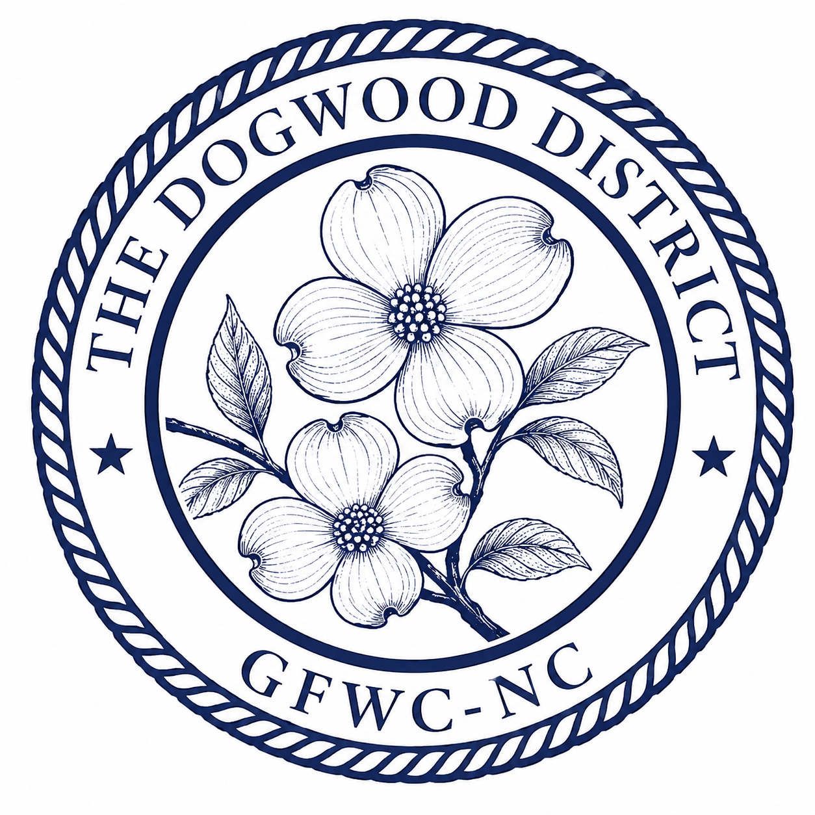

Brick Reformed Church
3699 Brick Church Rd. Burlington, NC 27215

District members serving GFWC-NC and all Clubwomen of the Dogwood District are called to the Fall Meeting to be held at the Brick Reformed Church Fellowship Hall located at 3699 Brick Church Rd. Burlington, NC 27215, on Saturday, September 26, 2026, hosted by the Dogwood District Executive Committee. District Officers, District Community Service Program (CSP) Chairs, District Committee Chairs, Club Presidents, Club Officers, Club CSP Chairs and all District Clubwomen are invited to attend.

Christy C. Frisbee

GFWC-NC Dogwood District President
Clc0311@yahoo.com
919-749-3362

FALL MEETING SCHEDULE

9:00-10:00 am  9:30 am  9:40-10:00 am  10:00-10:30 am  1  10:30-10:40 am  10:40-11:40 am  11:40-12:00 pm  12:00-12:45pm  12:45-1:00 pm | Registration & Breakfast  Meeting ambassadors meet with Leah Martin, Dogwood District Junior Director  Junior Buzz Session  Call to Order, Welcome & Business  - Greetings from GFWC-NC: Cindy Hewett, GFWC-NC President  - Roll Call  - Approval of GFWC-NC Dogwood District Standing Rules  - Election of the 2028-2030 Dogwood District Nominating Committee  GFWC Unity Projects and Pledge: Angela Moss, Dogwood District Programs  GFWC-NC Plenary Workshops: MASTERS Program, Technology and Leadership  Speaker: Robin Leonard, Expansion Coordinator Isaiah 117 House  International Day of Service Project: Hope for Justice Friendship Bracelets  Announcements, Door Prizes, Closing & Adjournment
REGISTRATION: Return this form with $15.00 per clubwoman (includes breakfast and coffee) by Monday, September 18th to Jodi Haire, GFWC-NC District VI Treasurer, 9104 O’Neal Road, Raleigh, NC 27613, jodihaire11@gmail.com, 919-612-4878.
- Make checks payable to GFWC-NC Dogwood District.
- PayPal: GFWCNCDistrict6@gmail.com In “what is this for” section, include Dogwood District Fall Meeting, your first and last name, and your email address (for any questions if needed). Under “Choose Payment Type” please choose “For Friends and Family” (this is very important. If Friends and Family is not chosen, you will need to reimburse the district for fees incurred).

Please note: Ambassadors must register, but do not pay the registration fee.

Name of Club :_____________________________________________

Clubwoman | Position | Amount Paid

Meeting Ambassadors: Clubwomen willing to serve as Ambassadors for the Fall Meeting should contact Leah Martin, Dogwood District Junior Director, leahmartin27526@gmail.com or (908) 328-6690, by Monday, September 18^{h}. Note: Ambassadors do NOT pay the registration fee.

Quorum: Quorum to conduct business at district meetings will be 40 members representing 9 different clubs

GFWC-NC Dogwood District Nominating Committee: By September 18th, each club president should submit ONE name for the district nominating committee. Club nominees for the Dogwood District nominating committee will be placed on a ballot and voted on at the Dogwood District Fall Meeting. The FIVE nominees who are elected will form the Dogwood District nominating committee and the one with the most votes will act as the chair. No member shall serve two consecutive terms. Each nominee shall have consented to serve, if elected.

GFWC-NC Dogwood District Administration Manual: An electronic copy of the GFWC-NC Dogwood District Administration Manual will be sent to the Dogwood District board of directors by September 28, 2026. Any other clubwoman can receive a copy by sending an email to Faith Junghahn, Dogwood District Secretary, at faith.junghahn@hotmail.com

Announcements: During the Announcement portion of the meeting, clubs are invited to announce any club events or projects they wish to share.

Door prizes: The following clubs are asked to bring a wrapped door prize to the Dogwood District meeting. They will be collected at the registration table.

Charlotte JWC Mary Stewart WC
Charlotte WC WC of Raleigh
Fuquay-Varina JWC
Fuquay-Varina WC
.

Donations: Clubwomen are asked to bring gift cards (Target, Walmart, Amazon, fast food) to benefit Isaiah 117 House.

Items to bring to the meeting: Gift Cards and Door Prizes if your club is listed, anyone is welcome to bring a door prize if they choose—the more the merrier!

REMINDERS:
- LEADS Applications are due to the District Chair (Jennifer Brighton; jbrighton.gfwcnc@gmail.com) no later than November 1.
- GFWC Membership Recruitment forms due to GFWC & GFWC-NC 2nd VP by December 1.
- Club Dues and Rosters are due to GFWC-NC Headquarters by December 31, 2026.
- Honor Club donations must be paid by December 31.

